Establishing a Bluetooth Connection Between Two EV3 Robots

Purpose: The first step in utilizing robot-to-robot communication with EV3 robots using Bluetooth is to connect the robots together.

Most of the instructions here use screenshots from EV3 tutorials. You can’t find the tutorial in the lobby of the Education version of EV3, you have to click a link from within the Messaging tutorial in Robot Educator.

For best results I usually turn off the iPad/iPhone Bluetooth feature on both robots.

I have found that one thing that affects initial connections is battery power. This is totally anecdotal from my classroom, but just to be safe, I would make sure you are working on a full charge.

Step 1 – Navigate to correct screen

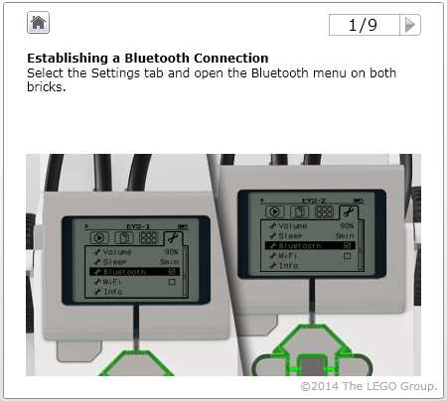
The Bluetooth menu is on the fourth (from left) tab, also called the settings tab. Choose it on both robots.

Step 2 – Make sure the correct Bluetooth settings are chosen on both robots.
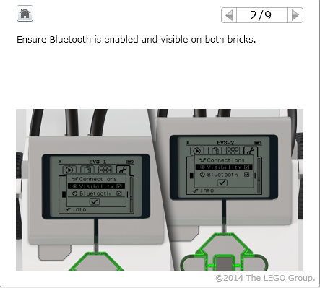
This is the same screen where I uncheck the box for iPad/iPhone.
You can’t see it in this screenshot however.

Step 3 – On one robot (I usually choose the one that will be sending messages first) choose Search from the Bluetooth menu.

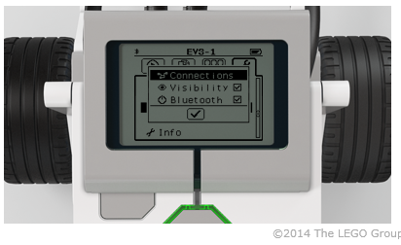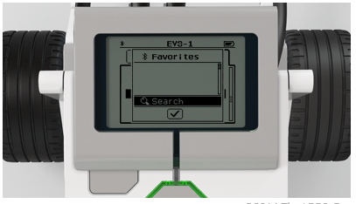
First you must click “Connections,” then you click “Search.”

Step 4 – Connect the robots

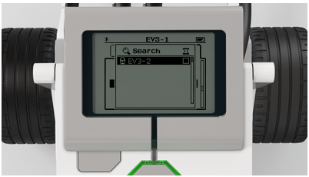
Find the name of the robot you are searching for. In this example it is EV3-2. By clicking on the name of the robot you want to connect to, it will initiate the connection procedure.

Step 5 – Accept the connection

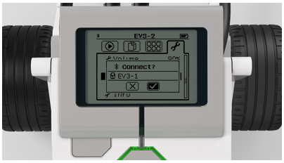
On both robots you will be asked if you want to accept the connection. Choose the default bolded checkmark.

Step 5 – Verify the passkey and you’re done!
On both robots this screen will pop up with a passkey of “1234.” This is not a case where you have to get sophisticated with passwords. Just click the checkmark to choose this default.
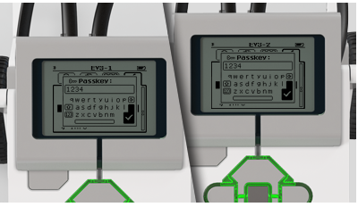

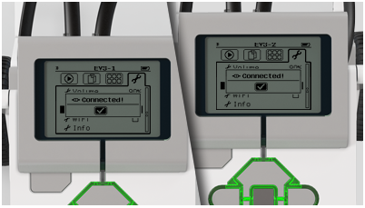
If you’ve made a successful connection you will see this screen pop-up on both robots. Click the check mark and you are ready to get started! See the “Simple Bluetooth Programming” handouts for some ideas on what to do next.

